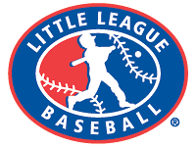
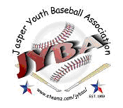
JASPER YOUTH BASEBALL ASSOCIATION
2019 SPONSORSHIP FORM

It is through sponsorships that JYBA is able to provide reasonable registration fees and maintain the park for use. Jasper Youth Baseball Association is a 501(c)(3) non-profit organization – meaning your generous
contribution not only supports the community, it is also tax deductible.

TEAM SPONSORSHIPS - $300 Team Name: ___________ League: _________

TEAM SPONSOR +
OUTFIELD BANNER - $400 (3 ft. X 5 ft.) Field: ______________

BANNER ONLY $200 (3Ft. X 5 Ft) Field:_______________

FOUL POLE - $200 Field: ______________

DUGOUT - $500 (4 ft. x 8 ft.) Dugout: ____________

Banner, foul pole, website and dugout sign logos and information should be emailed to chasity_shillings@yahoo.com
All sponsors will have their name listed on our website sponsor page @ http://www.jasperyouthbaseball.com

Checks only Please.

Company Name: ____________________________________________
Business website address: _____________________________________
Contact Name: ______________________________________________
Contact email: ______________________________________________
Address: _________________________________
City: ________________________ State: _______
Zip: _____________
Phone: _________________________
Fax: ____________________________

Would you like a receipt mailed to you? (Circle) Yes No

Please submit Sponsorship forms no later than March 10, 2018.

Anonymous donations will be taken in confidence.

Remit to:

Jasper Youth Baseball Association
P.O. Box 1513
Jasper, TX 75951

If you have any questions or would like to speak in person about a sponsorship please contact
Chasity Shillings chasity_shillings@yahoo.com 409-382-0847

